**Feeback 19: Remaining of feedback 14, 15, 16,17,18 – 05/12/2024**

**Education and Certifications**

**For General Certifications/Licences:**

When you bring and change, like adding or removing a certification, uploading or deleting a fille: When you save at the end:the change are registered but there is not the pop up success message: Please add the success message as well for **General Certifications/Licences.**

When you remove a general certification or when you remove an added certification/licence: all files uploaded should be automatically deleted.

For now when you remove a general certification or delete an added certification/licence with uploaded files, and then chose again the same general certification or add a new certification/licence 1, then when you add a new file then all the old files pop up again.

**Please correct this issue in all site where the upload file apply.**

**Mandatory Training and Continuing Education**

**Completed Mandatory Training:**

When you delete a training: all files uploaded should be automatically deleted.

For now when you delete a training 1 with uploaded files, and add a new training 1, then when you add a new file then all the old files pop up again.

Even though you delete the training 1 and also save the change, then then when you add a new file then all the old files pop up again.

To be able to upload the new file for training 1, we need first to delete all the uploaded files, save change, and then we can only upload the new files.

**Mandatory Continuing Education**

Same issue than previous:

When you delete a continuing education: all files uploaded should be automatically deleted.

For now when you delete a continuing education with uploaded files, and add a new continuing education, then when you add a new file then all the old files pop up again.

Even though you delete the continuing education 1 and also save the change, then then when you add a new file then all the old files pop up again.

To be able to upload the new file for continuing education, we need first to delete all the uploaded files, save change, and then we can only upload the new files.

When you save at the end, the new uploaded page show **Mandatory Training and Education but the left menu jump on profile instead to stay at Mandatory Training and Education button:**

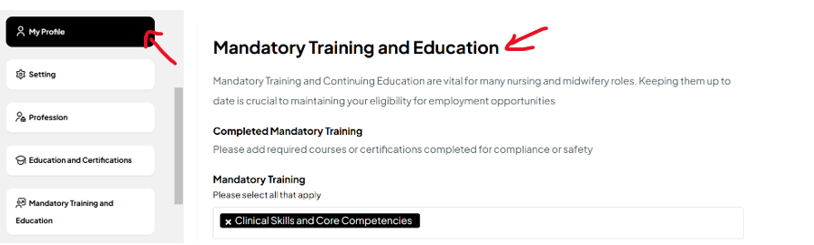

**Mandatory Continuing Education**

**Specialized Areas:**

**IF Specialized Areas selected and when you select all sub menus, then the page bug, and block the site:**

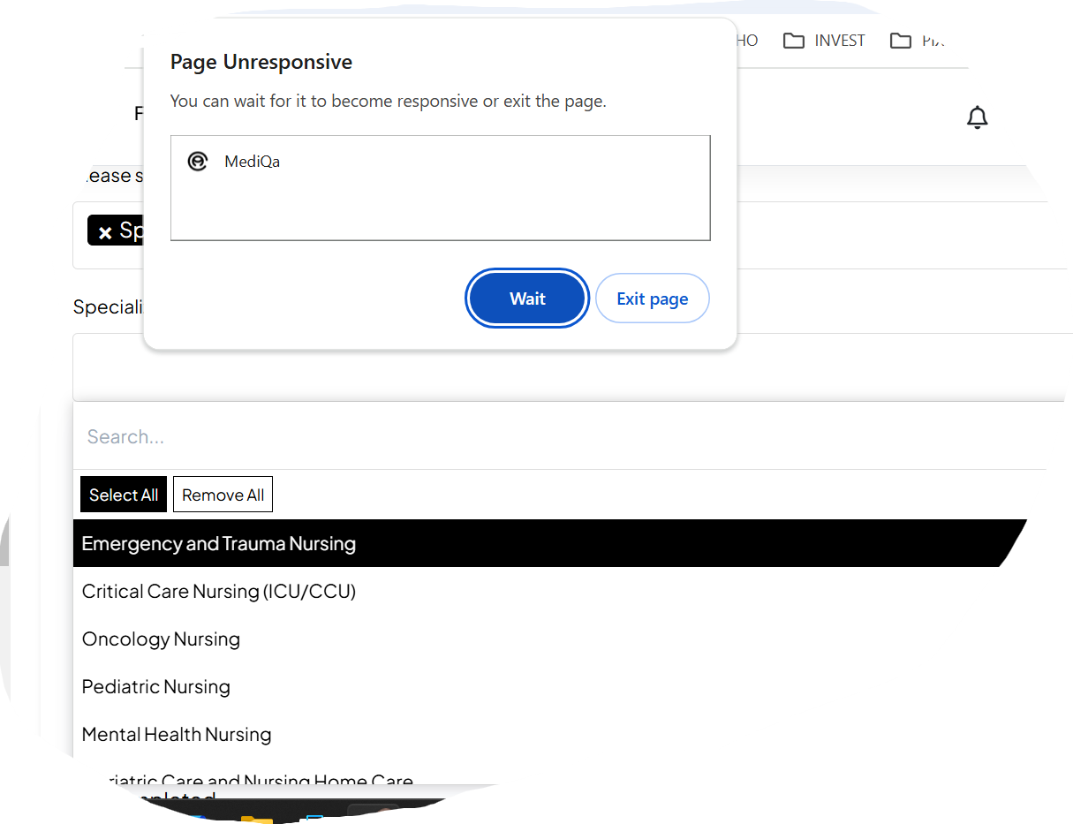

**This are sub section for Specialized Areas:**

Emergency and Trauma Nursing

Critical Care Nursing (ICU/CCU)

Oncology Nursing

Pediatric Nursing

Mental Health Nursing

Geriatric Care and Nursing Home Care

Substance Abuse and Addiction Counseling

Chronic Disease Management (e.g., Diabetes, Hypertension)

Advanced Wound Care and Ostomy Management

Public Health and Community Nursing

Home Health and Hospice Care

Operating Room/Perioperative Nursing

Telehealth and Virtual Healthcare

Obstetric Anesthesia Management

LGBTQ+ Health and Care

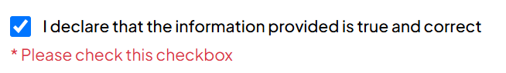

**I declare that the information provided is true and correct:** It should be mandatory, but once it is ticked, it can stay ticked, no need to ask again to tick for the other changes of the section.

**Experience:**

**After this sentence: Please add your full nursing work experience to strengthen your profile and get hired faster. Please keep update as your experience grows:**

Please Add: **Work Experience 1**

Type of nurse and specialties should be the same falling tree system than in Profession and register nurse:

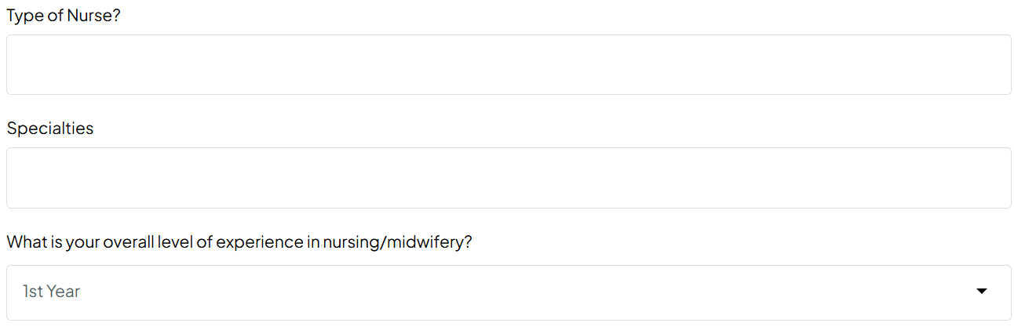

Please add:

What is your Level of experience in this specialty: (**Missing)**



Adults, Maternity OB/GYN/MFM, Paediatrics Neonatal Perinata,l Community: Should pop up only when selected, please use the same tree system than in Profession and register nurse:



**Remove Previous Employers** before Position Held

Employment Type:

**Permanent:**

**Temporary:**

If **Permanent:** selected:

Full-time

Part-time

Agency Nurse/Midwife

Freelance

Local

Volunteer

If **Temporary:** selected:

Temporary

Contract

Term Contract

Travel

Per Diem

Local

On-Call

PRN (Pro Re Nata)

Casual

Locum tenens (temporary substitute)

Agency Nurse/Midwife

Seasonal

Freelance

Internship

Apprenticeship

Residency

Volunteer

For each work experience **: After Detailed Job Descriptions, please add those fields:**

**Areas of Expertise**

Specific skills and competencies

Type of evidence

Upload evidence **Choose file:** For each work experience (Always possibility to delete the uploaded files)

**+Add another work experience:** button has to be placed at the end, after upload evidence and choose file.

**Please add** the possibility to delete added another work experience: For now you can just add but you can’t delete the added work experience.

When you **+Add another work experience, then** Update dynamically as the user adds work experience**: Work Experience 2, Work Experience 3,…..**

**References:**

When you +Add another Referee2, Referee 3, referee 4, after when you delete them back to referee1, after when you add another time, it is Referee 5 instead of Referee 2.

**MY PROFILE:**

Please remove Google home address:

**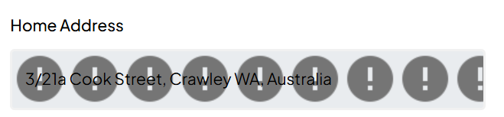**

**Vaccinations: See feedback 16 sent on the 30/10/2024**

**Work Clearances: I’m working on the content, I will send you soon**

**Professional Memberships:**

**Interview:**

**Personal Preferences:**

**Job Search & Personal Preferences:**

**Testimonial and Reviews:**

**Additional Information:**